Họ và tên: ………Trần Gia Nguyên Phong …………………………. MSSV: ………22002575……………
LAB WEEK 06: Machine-Level Representation of Programs

Practice Problem 3.1
Assume the following values are stored at the indicated memory addresses and registers:

Fill in the following table showing the values for the indicated operands:
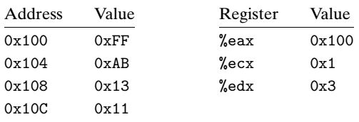

Operand | Value
%eax | 0x100
0x104 | 0xAB
$0x108 | 0x108
(%eax) | 0xFF
4(%eax) | 0xAB
9(%eax,%edx) | 0x11
260(%ecx,%edx) | 0x13
0xFC(,%ecx,4) | 0xFF
(%eax,%edx,4) | 0x11

Hint:
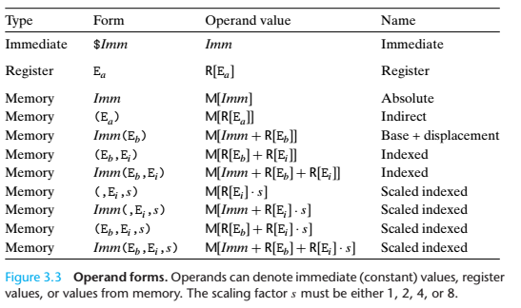

Practice Problem 3.2
For each of the following lines of assembly language, determine the appropriate instruction suffix based on the operands. (For example, mov can be rewritten as movb, movw, or movl.)
1 movL %eax, (%esp)
2 movW (%eax), %dx
3 movB $0xFF, %bl
4 movB (%esp,%edx,4), %dh
5 pushL $0xFF
6 movW %dx, (%eax)
7 popL

Practice Problem 3.3
Each of the following lines of code generates an error message when we invoke
the assembler. Explain what is wrong with each line.
1 movb $0xF, (%bl) # cannot use %bl as address register
2 movl %ax, (%esp) # mismatch between instruction suffix and register ID
3 movw (%eax),4(%esp) #cannot have both source and destination as memory reference.
4 movb %ah,%sh #no register named %sh
5 movl %eax,$0x123 #cannot have immediate as destination
6 movl %eax,%dx # Destination operand incorrect size
7 movb %si, 8(%ebp) #mismatch between instruction suffix and register

Practice Problem 3.6
Suppose register %eax holds value x and %ecx holds value y. Fill in the table below with formulas indicating the value that will be stored in register %edx for each of the given assembly code instructions:

Instruction | Result
leal 6(%eax), %edx | 6+x
leal (%eax,%ecx), %edx | X+y
leal (%eax,%ecx,4), %edx | X+4y
leal 7(%eax,%eax,8), %edx | 7+9x
leal 0xA(,%ecx,4), %edx | 10+4y
leal 9(%eax,%ecx,2), %edx | 9+x+2y

Practice Problem 3.7
Assume the following values are stored at the indicated memory addresses and registers:

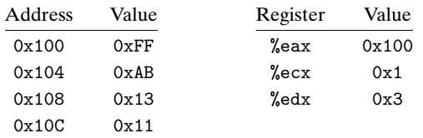

Fill in the following table showing the effects of the following instructions, both in terms of the register or memory location that will be updated and the resulting value:

Instruction | Destination | Value
addl %ecx,(%eax) | 0x100 | 0x100
subl %edx,4(%eax) | 0x104 | 0xAS
imull $16,(%eax,%edx,4) | 0x100 | 0x110
incl 8(%eax) | 0x108 | 0x14
decl %ecx | %ecx | 0x00
subl %edx,%eax | %eax | 0xFD

